Pan Am/Para-Pan Am Kids Activity Day Kit

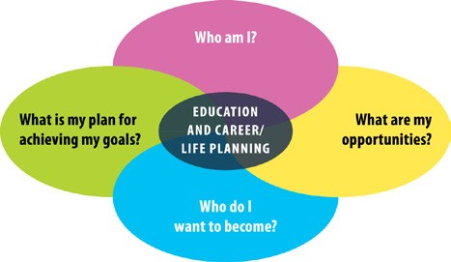

A Link to the OSP Essential Skills and Work Habits

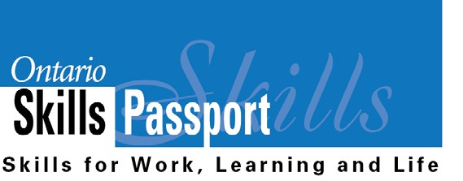

Participants will use a variety of Essential Skills and work habits before, during and after each activity. Teachers can help students connect the Essential Skills and work habits they are demonstrating in the Pan Am activities to activities they do in everyday life and occupations of interest. Identifying and reflecting on the Essential Skills and work habits demonstrated in the Pan Am activities will help learners develop their “All About Me” portfolio as they answer the four education and career/life planning inquiry questions: ***Who am I? What are my opportunities? Who do I want to become? What is my plan for achieving my goals?***

Summary of Pan Am/Para-Pan Am Activity Kit Links to Essential Skills

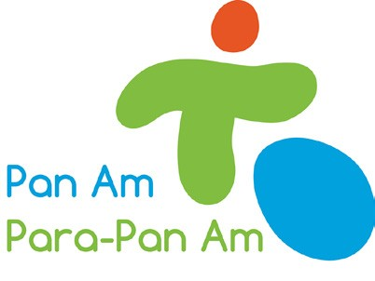

|  |  |  |  |  |  |  |  |  |  |  |  |  |  |  |  |
| --- | --- | --- | --- | --- | --- | --- | --- | --- | --- | --- | --- | --- | --- | --- | --- |
|  | Reading Text | Writing | Document Use | Computer Use | Oral Communication | Money Math | Scheduling or Budgeting and Accounting | Measurement and  Calculation | Data Analysis | Numerical Estimation | Job Task Planning and  Organizing | Decision Making | Problem Solving | Finding Information | Critical Thinking |
| Cooperative Volleyball |   |   |   |   |   |   |   |   |   |   |   |   |   |   |  |
| Batter Up |   |   |   |   |   |   |   |   |   |   |   |   |   |   |  |
| Bowlerama |   |   |   |   |   |   |   |   |   |   |   |   |   |   |  |
| Fast Break Lacrosse |   |   |   |   |   |   |   |   |   |   |   |    |   |   |  |
| Boccia Zone |   |   |   |   |   |   |   |   |   |   |   |   |   |   |  |
| Wicket Cricket |   |   |   |   |   |   |   |   |   |   |   |   |   |   |  |
| Energy Source |   |   |   |   |   |   |   |   |   |   |   |   |   |   |  |
| Pass Ball |   |   |   |   |   |   |   |   |   |   |   |   |   |   |  |
| Target Ball |   |   |   |   |   |   |   |   |   |   |   |   |   |   |  |
| Athletics Relay |   |   |   |   |   |   |   |   |   |   |   |   |   |   |  |
| Team Rally Tennis |   |   |   |   |   |   |   |   |   |   |   |   |   |   |  |
| Kickball |   |   |   |   |   |   |   |   |   |   |   |   |   |   |  |
| Dance Machine |   |   |   |   |   |   |   |   |   |   |   |   |   |   |  |

Work Habits Demonstrated

|  |  |  |
| --- | --- | --- |
| **OSP Icon** | **Work Habit** | **Examples** |
|  | Working Safely | • Wear appropriate footwear and clothing for being active.  • Drink water to keep hydrated. |
|  | Teamwork | • Work willingly with others to engage in friendly competition.  • Pass the ball to other players so everyone has a fair chance to play. |
|  | Reliability | • Follow rules of the games.  • Follow safety procedures.  • Return the equipment you use so it is ready for the next class/group. |
|  | Organization | • Organize the equipment you will need for an activity. |
|  | Working  Independently | • Follow the steps to get ready for the activity.  • Look after your own equipment. |
|  | Initiative | • Look for ways to assist other students.  For example, help primary students tie their shoes or get equipment. |
|  | Self-advocacy | • Ask questions to help you understand the rules or the expectations.  • Ask for help when you need it. |
|  | Customer Service | • Use respectful language when working with teammates.  • Show good sportsmanship and demonstrate a positive attitude. |
|  | Entrepreneurship | • Don’t give up – keep trying!  • Think of new ways to improve the way activities are planned. |

Essential Skills Demonstrated

|  |  |  |
| --- | --- | --- |
| **OSP Icon** | **Essential Skill** | **Tasks** |
|  | Reading Text | • Read instructions on the activity cards.  • Read information from websites to learn about the sports and the  history of the Pan Am Games. |
|  | Writing | • Write up safety rules to be posted in game play area.  • Write out a sequence of dance steps for the Dance Machine activity.  • Write responses to the reflection questions in the Teacher’s Guide.  • Write a research report connected to the Pan Am games, the history of  a sport, etc. |
|  | Document use | • Read labels (e.g. food labels, gym storage labels).  • Read batting order and equipment lists. |
|  | Computer Use | • Use digital devices (with permission) to take videos (e.g. dance routines, playing games) that could be shown at an assembly.  • Prepare a report on your research using a word processing  application.  • Access websites (e.g. Toronto2015.org) and digital resources to  complete research. |
|  | Oral  Communication | • Use the information in the Eating Well with Canada’s Food Guide  resource to discuss the four food groups.  • Discuss strategies with teammates, such as the best way to knock  over the pins in a bowling game.  • Give instructions to members of your team and listen and respond to  their questions.  • Teach other students how to play the game (e.g. Junior students teaching Primary students).  • Give an oral presentation to classmates (e.g. research findings, summary of data analysis).  • Participate in class discussions about the activities.  • Discuss responses to the reflection questions in the kit. |
|  | Money Math | • Receive cash and provide change for fundraising events that your  school may want to run. |
|  | Scheduling or Budgeting and Accounting | • Determine how much money must be raised to purchase Boccia  balls and other equipment for these games.  • Create the schedule of events for a school-organized Pan Am  Games (e.g. play day centered around Pan Am activities).  • Schedule the timing of the player shifts connected with activities to  ensure everyone gets equal playing time. |
|  | Measurement and  Calculation | • Measure accurate distances as per instructions for each Pan Am activity.  • Calculate quantities of equipment and supplies required for each activity.  • Calculate variations on given measurements to accommodate larger  or smaller available spaces.  • Keep score during each activity. |

|  |  |  |
| --- | --- | --- |
| **OSP Icon** | **Essential Skill** | **Tasks** |
|  | Data Analysis | • Track and analyse statistics from each game (e.g. number of hits per person or team).  • Complete a probability analysis for each game (e.g. When creating teams by chance, what is the likelihood that the entire team will be all girls?). |
|  | Numerical  Estimation | • Estimate the amount of food to purchase for the Energy Source Activity  so that enough food is available.  • Estimate how long it will take to complete each rotation or rally or activity.  • Estimate the number of successful completions of a task  (e.g. number of successful rallies in Cooperative Volleyball, successful bats in Batter Up, etc.)  • Estimate the distances required for setting up each game  (e.g. How far is 1 metre and can we accommodate a 40 metre field?). |
|  | Job Task Planning  & Organizing | • Plan a dance sequence with a partner during the “Dance Machine”  activity.  • Help plan teams, positions and rotations. |
|  | Decision Making | • Select equipment that works for you. For example, select a ball that is  lighter or easier to roll.  • Decide which strategy will help you succeed in the various activities (e.g. which ball to target in Boccia Ball or should you roll or toss a ball for success).  • Select a research topic and decide what information is important to  present.  • Use digital devices to take a series of pictures of one activity and arrange the pictures to show the sequence of steps, from start to finish. |
|  | Problem Solving | • Collaborate with peers to adapt games so they can be safely played at school (e.g. Adapting Target Ball so it doesn’t include blindfolds).  • There is not enough space for a certain activity. Collaborate with peers to adapt games so they can be played at your school (e.g. using scoops instead of lacrosse sticks).  • There is a conflict over the rules of the game. Look at the rules again or  ask a teacher to clarify.  • Some of the activities require equipment that the school does not have.  Substitute different equipment or ask if there are funds to purchase new equipment. |
|  | Finding Information | • Conduct research, using a variety of sources (e.g. sports, teams, players, history of games, etc.).  • Interview or ask meaningful questions of members of the community, volunteers or guest speakers to find out more about the sports you are researching. |
|  | Critical Thinking | • Analyse the game and provide ideas for how to adapt activities to make  them easier, more challenging or more interesting.  • Analyse videos of the activities to determine how to improve your team’s performance in the next game. For example, make a judgment that more offensive players are needed for kick ball. |

Problem-based Activities and Ideas

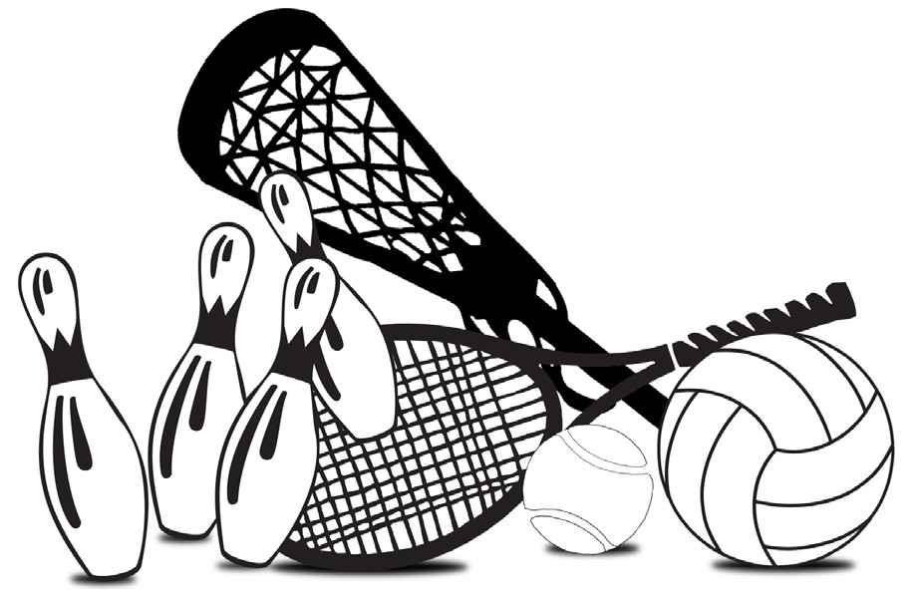

Participants are encouraged to think about the “skills, concepts and strategies they need” for each game (A Guide for Educators, page 15). Some ideas for problem-based activities are listed below.

Scenario 1

The school has $100 to purchase new equipment for the

Pan Am games activities. Look at the activity cards for each

game, review the equipment the school currently has and decide what equipment can be purchased within the budget. You may decide to cut certain activities based on student preferences.

The largest class in the school has 25 students.

Be sure to explain your choices.

Teacher Preparation

• Provide students with a list of the equipment that the school currently has on hand.

• Teachers may also wish to provide other supports, such as a list of websites where equipment can be

purchased.

• Please adapt the activities so they are appropriate to the age and strengths of the students.

|  |  |  |
| --- | --- | --- |
| **OSP Icon** | **Essential Skill** | **Task** |
|  | Writing | • Write survey questions to find out what activities will be the most popular  with students. |
|  | Document Use | • Review the list of equipment needed for each game. |
|  | Data Analysis | • Compare the equipment the school has on hand and the equipment needed for each game to find out what gaps need to be filled. |
|  | Reading Text | • Research websites to find the prices for purchasing any additional  equipment that is needed. |
|  | Computer Use |
|  | Finding Information |

|  |  |  |
| --- | --- | --- |
| **OSP Icon** | **Essential Skill** | **Task** |
|  | Scheduling or Budgeting and Accounting | • Compare equipment prices on different websites to determine the best  value. |
|  | Decision Making | • Select equipment to purchase based on price and student preferences  for the various events. |
|  | Money Math* | • Purchase fruits and supplies for the Energy Source Activity.  • Participate in role plays involving students purchasing new equipment  required to play the games.* |
|  | Oral  Communication |
|  | Writing | • Write a report summarizing your findings and explaining the equipment  choices you made. |
|  | Computer Use |

* If students participate in a role-play, this is a skill-building activity and they are working towards demonstrating Essential Skills tasks. If they take a field trip to a local market or grocery store to actually purchase items for the Energy Source Activity, then it is an Essential Skills task.

Scenario 2

Help plan and organize the events for the Pan Am school games.

Teacher Preparation

• Provide students with the number of students per class and



other information, such as the date of the event.

• If students have not completed Scenario 1, then please add tasks relating to the choice of events or simply provide students with a list of all events.

• Please adapt the activities so they are appropriate to the age

and strengths of the students.

|  |  |  |
| --- | --- | --- |
| **OSP Icon** | **Essential Skill** | **Task** |
|  | Oral  Communication | • Discuss ideas for how to adapt different activities for the age or size of  different classes. |
|  | Numerical  Estimation | • Estimate how long each class/group will spend on each activity. This  information will be used later on when you create a schedule. |
|  | Computer Use | • Create a table to keep track of equipment, estimated times for the  event, etc. |
|  | Scheduling or Budgeting and Accounting | • Create a schedule for each class listing the time of each event and what  equipment is needed. |
|  | Numerical*  Estimation | • Estimate how much food and drinks will need to be ordered for a food  booth.* |
|  | Scheduling or Budgeting and Accounting | • Prepare a budget for a food booth which details the cost of each item and the price to be charged. Be sure that you do not lose money! |
|  | Document Use | • Prepare a list of equipment needed for each activity |

|  |  |  |
| --- | --- | --- |
| **OSP Icon** | **Essential Skill** | **Task** |
|  | Writing | • Write a letter to parents giving them information about the day and what children need to bring (i.e. clothes and shoes for being active, etc.)  • Write a list of safety rules for each activity. |
|  | Job Task Planning  and Organizing** | • As a volunteer leader on the day of the event, you are responsible for making sure that the equipment and play area is ready for an activity. You are also responsible for making sure that the activity starts and finishes on time and that you report any problems to a staff supervisor. |
|  | Money Math* | • Receive cash and make change as a volunteer in the food booth |
|  | Critical Thinking | • Analyse your Pan Am School Games and provide ideas for how to adapt  activities to make them easier, more challenging or more interesting. |

*This task applies only if the school decides to run a water/food booth.

**This task applies only if the student is a volunteer leader on the day(s) of the event.

Pan Am/Para-Pan Am Reflection Worksheet

Name: Date:

|  |  |
| --- | --- |
| Who am I? | What Essential Skills and work habits did I develop and demonstrate?  What did I learn about myself from this experience? |
| What are my opportunities? | What other experiences can I pursue that can help me apply and further develop my Essential Skills and work habits? |
| Who do I want to become? | How do my Essential Skills and work habits prepare me for the  types of occupations that I have identified in my goals? |
| What is my plan for achieving my goals? | Are there any Essential Skills and work habits that I need to further  develop to achieve these goals?  What is my next step to further develop my Essential Skills and work habits? |

Save this reflection in your “All About Me” portfolio.

ontario.ca/skillspassport